Siddharth.KP   
 241501203 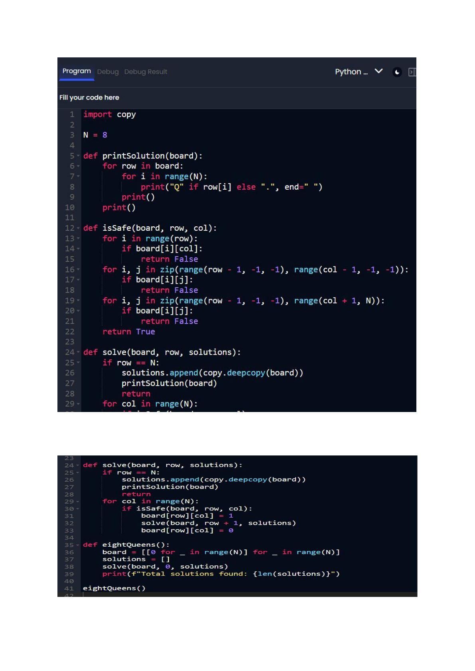

Siddharth.KP   
 241501203 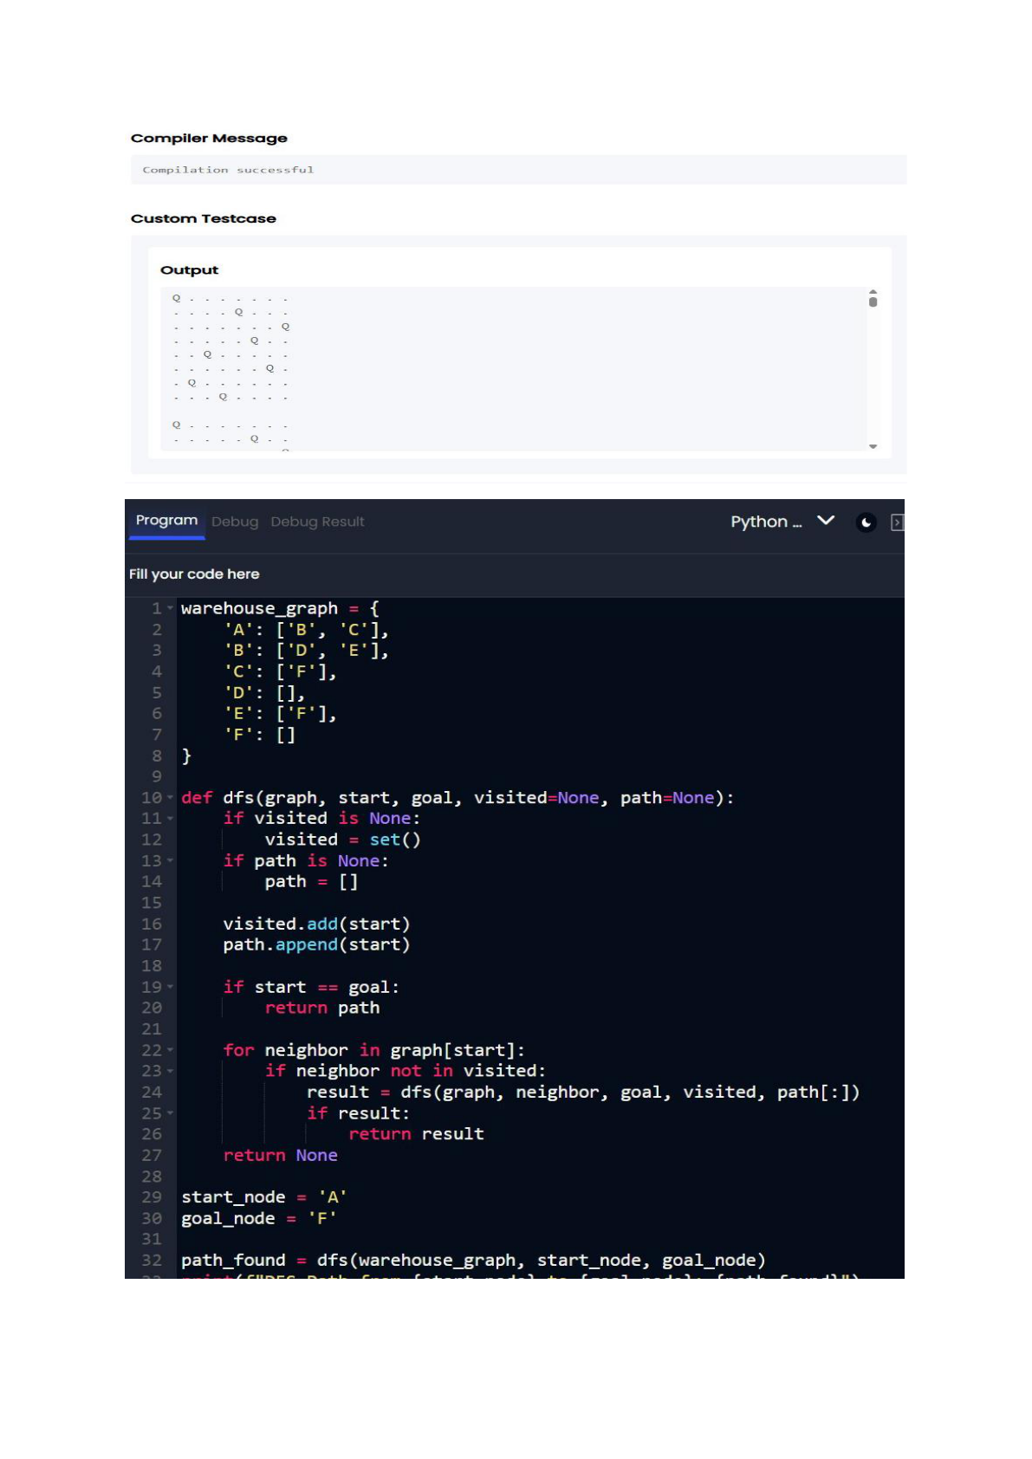

Siddharth.KP   
 241501203 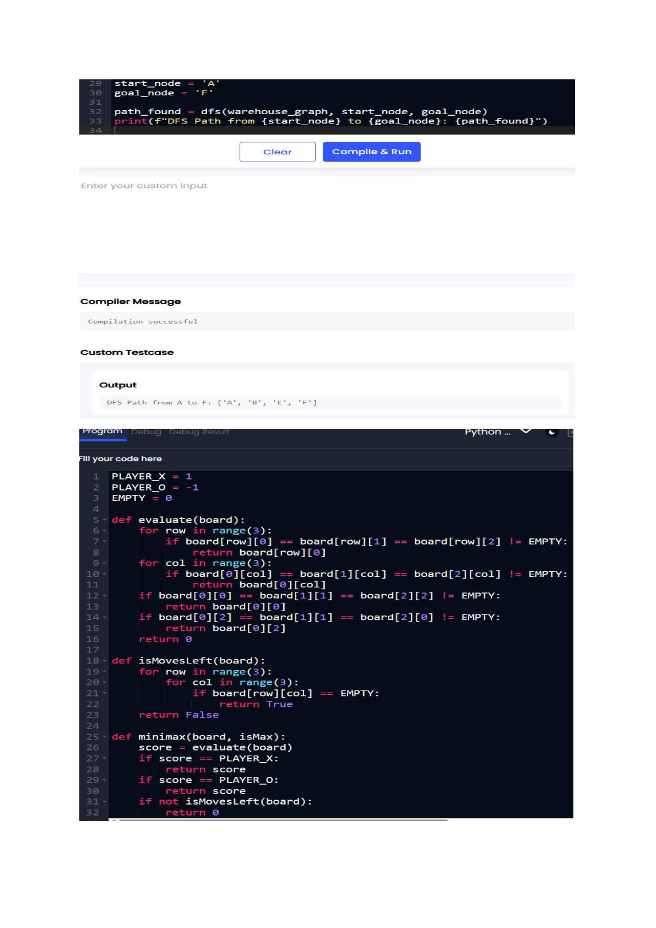

Siddharth.KP   
 241501203 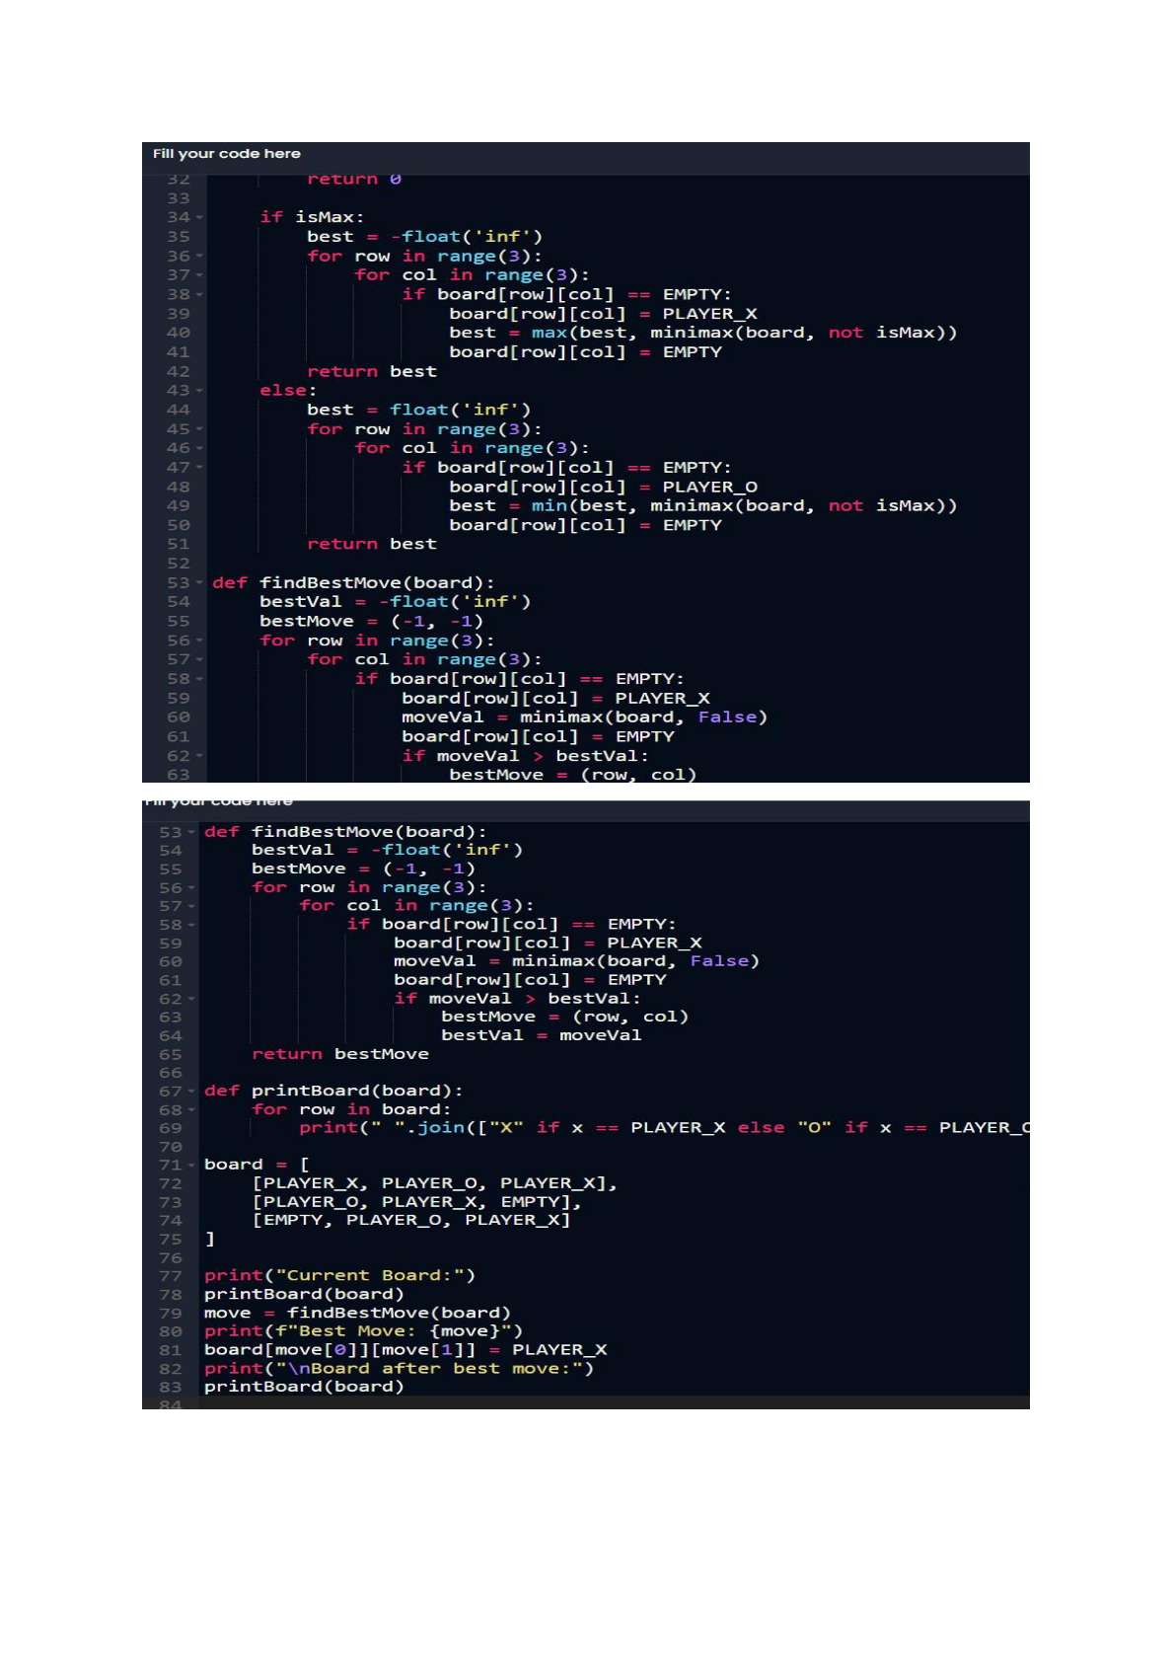

Siddharth.KP   
 241501203 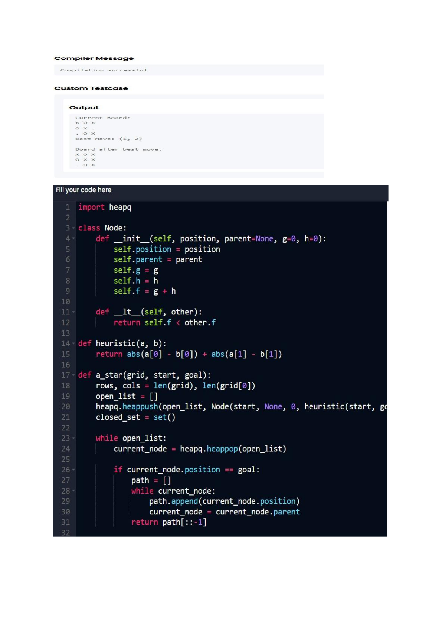

Siddharth.KP   
 241501203 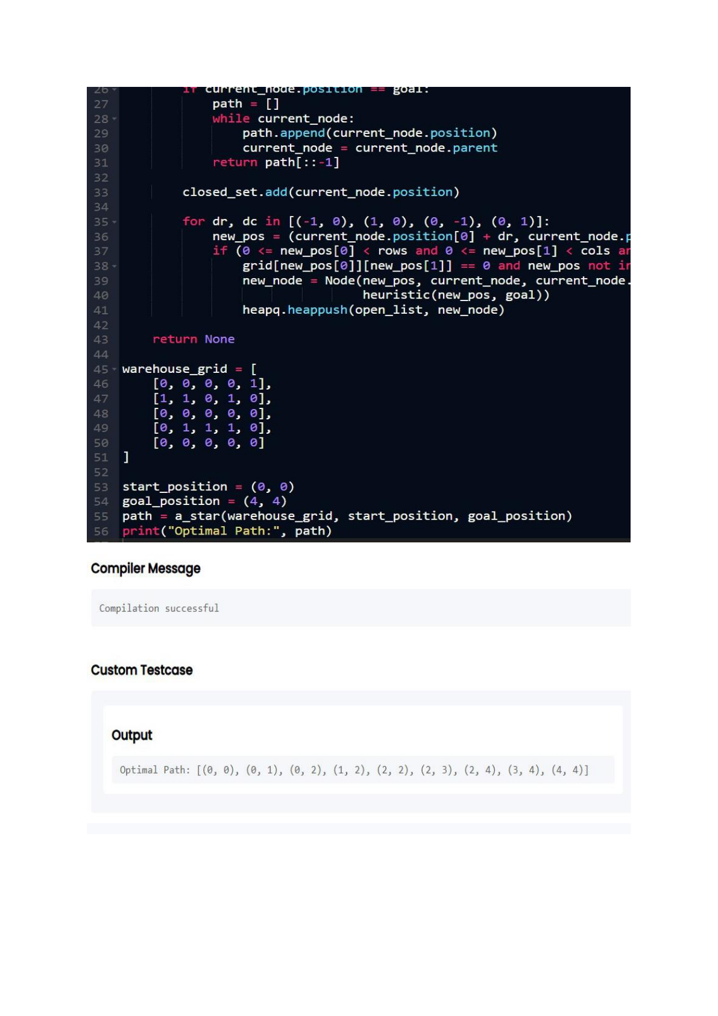

Siddharth.KP   
 241501203 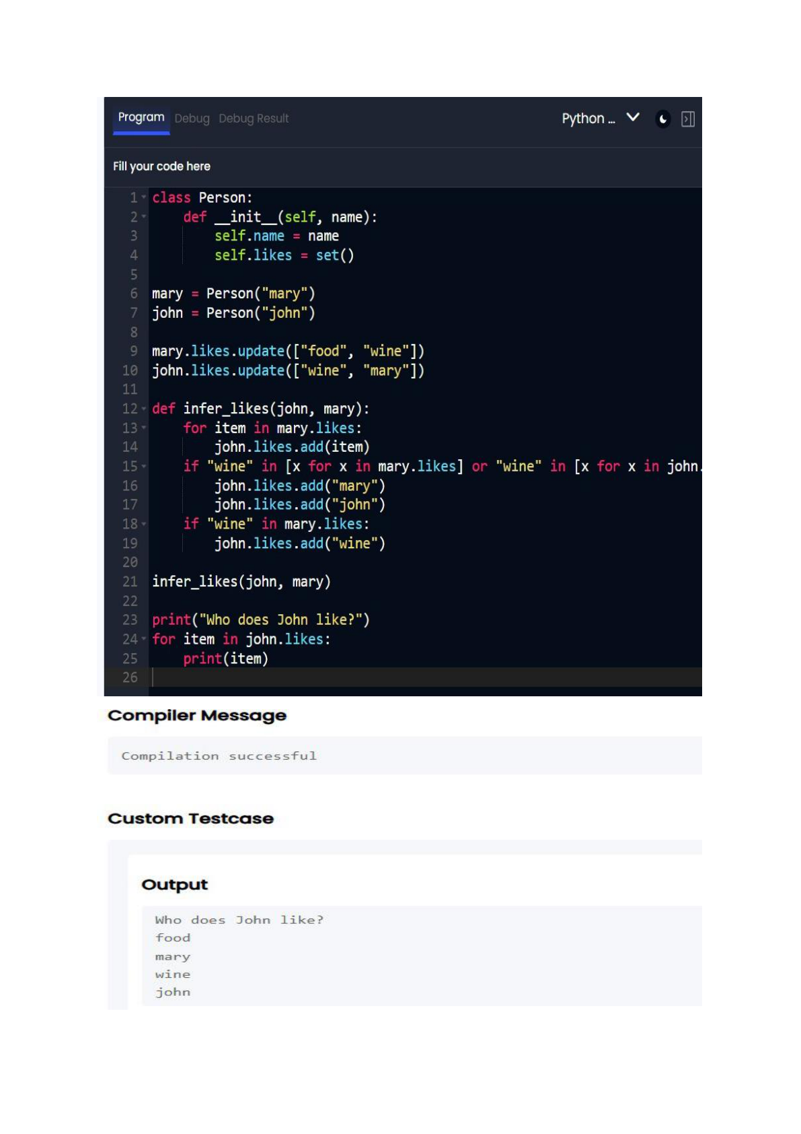

Siddharth.KP   
241501203

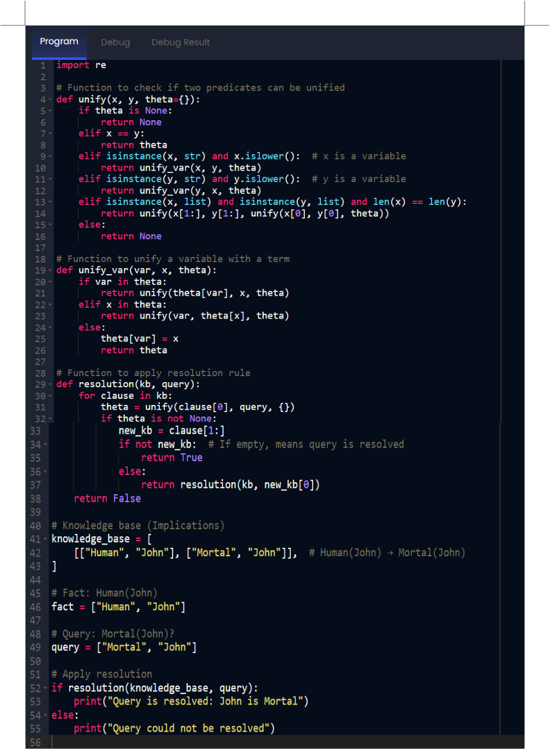

 

Siddharth.KP

|  |  |
| --- | --- |
| 241501203 |  |

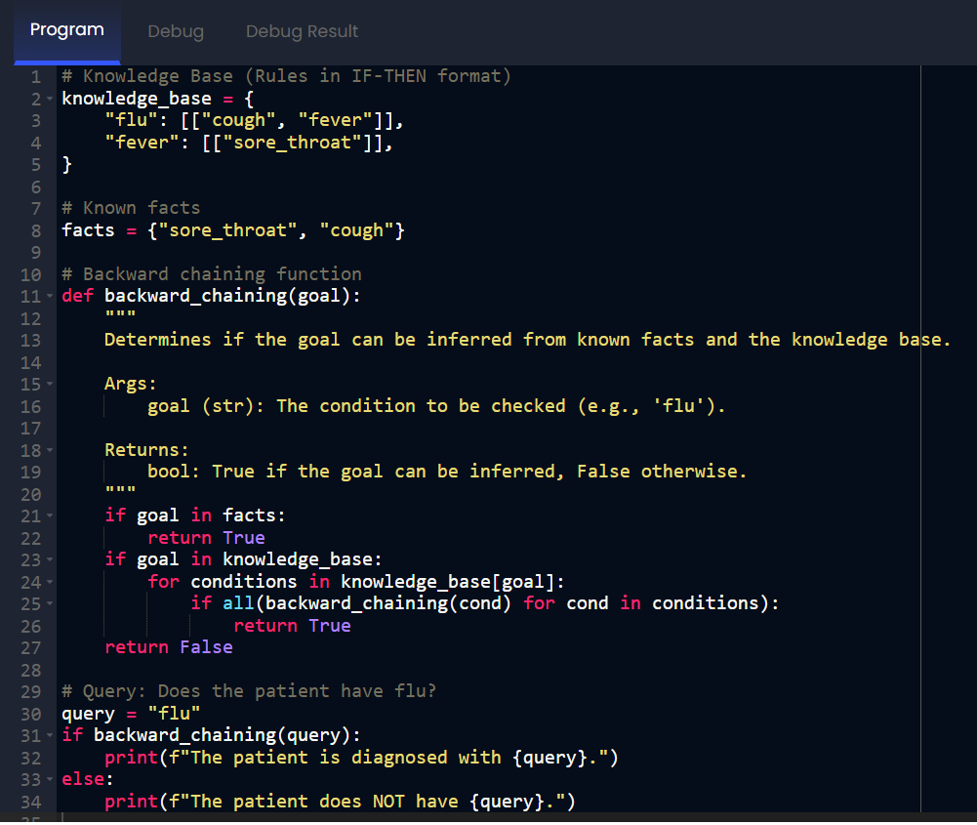

 

Siddharth.KP   
241501203 

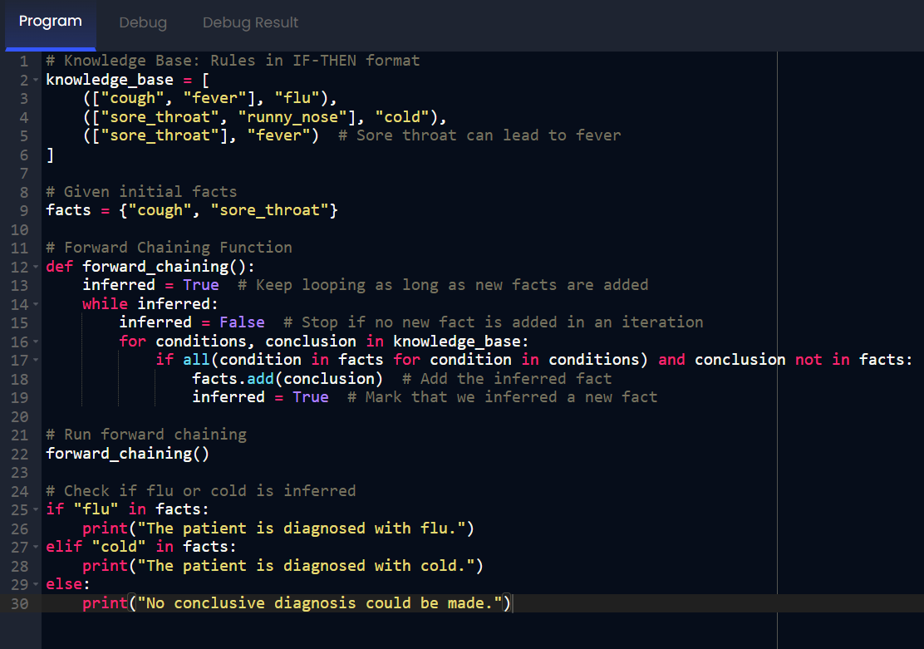

 

Siddharth.KP   
241501203 

 

Siddharth.KP

|  |  |
| --- | --- |
| 241501203 |  |

 